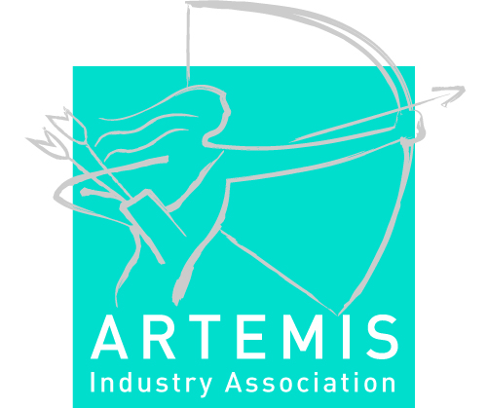
Preliminary draft Guide for Applicants to the ARTEMIS Centre of Innovation Excellence Label.

The application for the CoIE label must provide:
- An overview of the partners in the CoIE and indicate which partners do compete in the market and in which market(s) they do compete;
- Information on how the partners are positioned in the supply chain - knowledge providers, generic technology providers, systems developers, systems integrators, product companies;
- Information on which end-users are involved in the CoIE;
- The geographical scope of the CoIE;
- The CoIE policy document;
- The most recent action plan:
  - The action plan describes the main activities driving the Innovation system forward, such as common meetings, workshops, pre-studies/pre-projects, R&D projects, different interest groups (technology, branch etc), events etc…
  - The update cycle of the action plan;
- Letter of interest of each partner of the CoIE.

The application should make clear that Innovation and R&D in the CoIE are:
  - based on the strategy of “Open Innovation”;
  - fostering a culture of openness, trust, fairness and willingness to cooperate;
  - shared by the CoIE partners with common interests;
  - made visible to the outside world by means of common technology roadmaps and R&D strategies;
  - support the development of academic excellence;
  - fitting the ARTEMIS SRA (this should hold for the dominant research domain)
  - contributing to the EU competitiveness;
The above bullet-points could be addressed in the policy of the CoIE.

The application should also provide information on the following activities:
- Activities developed to build and maintain relations to other networks (the inter-cluster cooperation strategy) and the public authorities;
- Publish a yearly activity and progress report that describes, amongst others, the progress made on ARTEMIS label criteria
- Provide networking and matchmaking facilities to encourage frequent interaction and the initiation of cooperative R&D projects;

Not mandatory, but if applicable the application may describe the contribution of the CoIE to:
- standardisation;
- respect ecological principles, recognising real concerns about safety, energy usage and sustainability;
- actively stimulate more SME participation in the ARTEMIS innovation ecosystem(s) and enhance their growth and success;
- explore new business models for trading in the envisaged dynamic innovation environment, including incorporation of open source concepts;
- stimulate the establishment of open European Tool Platforms (q.v.) that can evolve and interoperate with other tool solutions;
- recommend adaptations to European educational systems and assist them to supply and sustain suitably skilled engineers and researchers;
- stimulate the opening of supply chains, where beneficial, to create a more open innovation environment by means of the ARTEMIS Innovation Ecosystems;

