Booth application form – DIF 2017

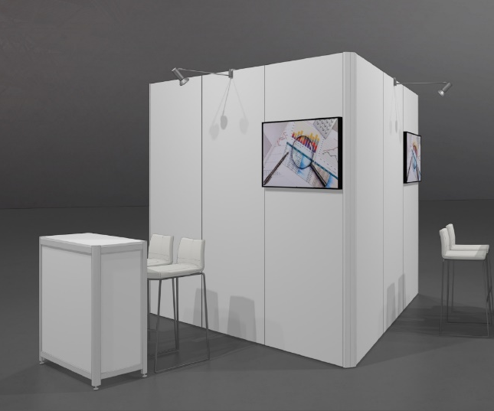
- Booth package:

Costs: EUR 1.500 excluding VAT

Booth package includes:
- booth walls 3m
- 1 LCD screen ~40”
- 1 counter desk
- 2 high chairs
- 3-power-socket
- 2 free entrance tickets

- Fill in the booth details:

Project name:
Project theme: (select one or more themes that correspond to your project)
Smart Cities + Smart Energy
Smart Mobility
Smart Healthcare
Smart Manufacturing
Contact name:
Company:
E-mail:
Telephone:
Invoicing address:
VAT number:

Project description (max 500 characters):

What will you show and how (max 500 characters):

- Sign the application form and send it before 31 January 2017 to info@artemis-ia.eu.

(signature)

Name: Date:

Terms:
Booth applications are subject to approval and are on a first come first serve basis.
By signing this form, you agree to the DIF booth package costs and eligibility requirements as listed on this application form.

