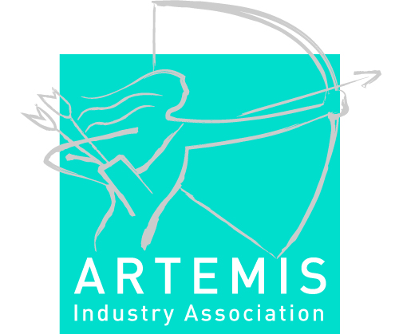

Criteria to be granted the “ARTEMIS Tool Platform (RTP)” Label by ARTEMIS-IA

Version V3
Status 10 February 2011

Table of contents
1. Introduction 2
2. Definition 2
3. Boundary Conditions 2
4. Label Criteria 2
5. Might Do 2
6. Process 2

Introduction

Tool Platforms are an instrument to support sustainability and productivity by sharing research results among projects targeting related objectives, thus contributing to the overall objective of promotion of cross-fertilization and reuse of technology results.
Unlike a complete design flow tool-chain, an ARTEMIS Tool Platform will not have a fixed or even physical existence. An ARTEMIS Tool Platform is not intended as a commercial entity. These virtual Platforms are sets of commonly agreed interfaces and working methods, which may evolve and become more refined over time, that allow specific tools addressing a particular element or phase of a design flow to interoperate with other tools addressing the same design goal, so forming a complete working environment. In its simplest expression, it is a specification for interfaces and operating methods. The demands on design tools can be very different between industrial sectors (indeed, even between companies within the same sector, due to product diversity), making a single ARTEMIS solution unrealistic. Therefore a number of ARTEMIS Tool Platforms are foreseen. Note that a development project can yield a tool or tools which is/are compatible with more than one Platform. Also, the Platform concept does not impose a specific business model.
Platforms may serve as an open standard for methods, processes and tool integration; they are used as such in pre-competitive R&D projects (i.e., ARTEMIS projects) to focus R&D activities and guarantee sustainability of project's results.
The complete strategy and policy on Tool Platforms is described in the document: “Artemis-IA Tool Platforms Strategy & Implementation V43”.
This document is intended to formulate the label certification criteria. It is therefore a stand-alone annex to this aforementioned document.

Value of the ARTEMIS Tool Platforms approach
The ARTEMIS tool platforms approach has been crafted to provide the best trade-off between key conflicting objectives:
- The need to support at best market requirements for a specific segment (one size does not fill all), while limiting tool platform proliferation
- The need for integration between solutions in order to support cross-segment integration
- The high cost of such integration
- The need to standardize to avoid the redundant cost of multiple plug-ins
- The need for innovation not to be inhibited by too wide or to early standards
- The need to preserve competition in key segments
- The need to provide an integrated set of on-line services to the end-user
- The need to evolve a tool platform after its initial deployment

Definition

Please note that ARTEMIS is using the generic word “Tool Platform” to designate the collaborative development environment of a tool chain that allow to design Embedded Systems (design / build time), in order to clearly distinguish them from “Embedded Software Target Hardware”, that are a set of embedded soft or hard constructs to enable various components to communicate and operate together (at run time).
The ARTEMIS R&D Tool Platforms for Embedded Systems will focus on pooling:
- Intellectual Property
- System, S/W and H/W Development Services (at build time), to help the ARTEMIS in-work projects to deliver their innovative Embedded Systems development applications across multiple disciplines and partner companies
- S/W Components (run-time usage), for the customer working with the applications resulting of ARTEMIS projects to help developing Embedded Systems.

Tool Platform Definition
“Tool Platforms” are set of services to a community enabling it to pool Intellectual Property, Methodology, Components or Services, in accordance with a specific architecture, in order to avoid duplicate efforts when developing, maintaining, or using them.

Boundary Conditions
In order to properly support sharing and pooling across a community, platforms need to support at least a majority of the following bullets:
- Tool Platform long term sustainability, i.e. data persistency.
- Tool Platform capability to ensure data validation, consistency, lifecycle, change propagation and configuration
- Tool Platform capability to support interoperability between the tool Products or Services proposed by the contributing members, interoperability with other tool platforms or the outside world, and the definition of conformance testing procedures to be applied to guarantee various predefined levels of interoperability
- Tool Platform capability to support the collaborative development processes across partners
- Tool Platform capacity to support dissemination
- Tool Platform capability for IP protection, re-use and licensing
Last, but not least, platforms must ensure that the various polled components do operate properly together, i.e. are able to maintain their quality of service when interoperating at runtime. Thus the platforms should as much as possible also provide the following services:
- Verification of compliancy to the appropriate architectural style
- Composition and connectivity architecture and services to guarantee the overall quality of service

Tool Platform Operations Management
- The intent is that tool platforms group large communities of contributors at build time, i.e. when shared IP, products or services are collaboratively defined.
- In this context, to ensure platforms readiness and availability, ARTEMIS recommends that Platforms are managed by a single responsible legal entity, or a set of entities bound by a consortium agreement.

Openness & Business model
- No prescription is made on Tool Platform business model
- No prescription is made on Tool Platform source code availability
- Tool Platforms Interoperability interfaces and/or exchange formats need to be made publically available

Platform maturity
- The objective is to support as well projects for relatively mature platforms and projects for new, innovative and therefore necessarily less mature platforms. In order to make the level of maturity of the platform visible to potential future platform users, it is recommended to qualify such level by using the TRL (Technology Readiness Level) index. The description of such index is given in appendix.
- There is no initial TRL level defined for the ARTEMIS RTP label.
- It is important that platform projects apply for labeling in their early stages (low TRL), because in the early stages, the alignment of the platform with Artemis priorities, and the planning of its integration with the other platforms are much easier and cheaper.

Label Criteria
This section describes criteria for labeling platforms as ARTEMIS Tool Platforms. Emphasis has been put on three points, namely
- to facilitate an early installment of initial tool platforms, that (initially) do not need to have market quality
- the integrating role of the Tool Platform in establishing ecosystems around tool development
- to ensure sustainability of platforms

Tool Platform providers
- The organization that provides the tool platform shall be uniquely identified. An Tool Platform is developed under the responsibility of:
- a single organization, such as for example a software vendor, a joint-venture, a not-for-profit organization, an open-source organization, or
- a consortium of such organizations under a common governance structure, which will be called here the ‘tool platform provider’. A description of the consortium must be given with the category of each partner (Large Enterprise, SME, Research Organisation).
- The tool platform provider may operate under various business models, such as self-funded, applying for public funding, open-source, or selling its software and services. The services of the provider supporting the platform should be clearly defined.
- The tool platform provider shall distribute all information needed to the partners wishing to integrate to his tool platform, such as API’s, documentation, support.

Tool Platform Information
Information should be provided on:
- The platform definition & open standards publication by the project consortium
- The platform implementations, which might be developed by the project consortium, and/or by S/W vendors and/or by Open Source bodies.
- The service levels offered to Tool Platform users together with the cost levels.
For each topic, the TRL (technology maturity level) must be given, since it is an important indicator for the community to assess the platform readiness.

Functional coverage
- Platform type (according to ARTEMIS-IA classification)
- Assignment to ARTEMIS sub-program(s)
- (Intended) functionality of the platform and its tools, including instruments to ensure interoperability
- The targeted industries and the lifecycle coverage: which part(s) of the product lifecycle is/are covered
- Policies for conformance tests of the tools, and/or interoperability across tool platforms. In order to go enforce conformance, Artemis will rely on the definition of standards, either promoting the definition of new International Standards, or participating to existing standards in order to make them support the new technologies
- TRL level of each tool in the platform, and the TRL level of the platform as a whole.

Integration concept
- Integration of existing tools into platform. Which tools are contained in the platform, which tools are foreseen for integration in the platform.
- Measures for targeted support of Interoperability Standards
- The scope of existing standards targeted, or the project of introducing new standards when appropriate
- The openness, completeness, simplicity of published or targeted API's to support planned interoperability or customization
- The integration of the platform in the ARTEMIS platform eco-system must be described:
- Positioning to labelled platforms
- Interfaces to labeled platforms
.

Information on plans for sustainable operation
- The concept for sustainable operations must be described, e.g.
  - which organizations supports the platform for
    - hosting & storage services
    - maintenance
    - plans for further development of the platform (optional)
  - ownership of processes to ensure platform value delivery and to manage platform evolutions (lifecycle)
  - business model for the tool platform support
  - measures that ensure dissemination of the platform
    - Dissemination to follow-up projects that
- use the platform
- perform further development of the platform
- Development plan for the platform, as the platforms are expected to show increasing TRL's over time. Should this not be the case, recovery plans will be requested.

Publish Tool Platform information
General Information
- Platform Objectives, targeted Industries, targeted Processes
- The Platform Type(s) (according to the Artemisia classification)
Technical Information
- Targeted Functional Capabilities
- Architecture
- Development Environment & Prerequisites
Delivery Mechanisms for end-user availability
- Maintenance and support mechanism
- Targeted Licensing conditions and licensing mechanisms
Planning Information
- The planned interoperability with the other declared Artemisia Platforms
- The planned End-User Deliveries, with Technology Readiness Levels (TRL’s)
- MarketExpected market perspectives (not detailed market analysis)

Might Do

Tool Platforms might contribute to:

Interoperability:
- Discuss and agree with various other Tool Platforms on common interfaces or components in order to facilitate interoperability between separate Tool Platforms.
Note: It is though recognized by ARTEMIS that the various tool platforms will very rarely be 100% interoperable. Taking onboard such objective would both dramatically slow down innovation and increase the costs. The goal is to share the subset of Interfaces that will provide at low cost the basic interoperability needed by the targeted cross-segments integration, while freely pursuing innovation for the most advanced or specialized functions (low-hanging fruits approach)

Innovation Ecosystem
- ARTEMIS objective is to develop an ecosystem of various communities around the ARTEMIS platforms. Tool Platform are encouraged to make innovative proposals toward this goal. Communities may come from : ARTEMIS-IA, Industry, SME’s R&D institutes & universities, Centers of Excellence, Public Authorities, etc.

Standards
- It is intended to leverage as much as possible current standards, or de-facto standards.
Tool Platforms are encouraged to contribute to International and European Standards.

Process

ARTEMIS-IA Organization
- ARTEMIS-IA will label a number of focus tool platforms, which meet the appropriate criteria of quality, scalability, value to support specific markets, etc.
- It is not the intention to label a too large number of platforms, as this would lead to a proliferation of solutions, which would be impossible to make properly interoperable.
- The ARTEMIS-IA Tool Platforms Working Group does not deal with content, but only with methodology. It will not favor any platform proposal. It will however publish a status of the candidate platforms in order to provide stakeholders with the appropriate visibility on consolidated information, and may formulate, to both the platform owners and the steering board, suggestions aimed at accelerating platforms convergence
- The role of Artemis is to promote the platform definition, implementations and interoperability, but Exploitation strategies for tool platforms are generally seen not be in the scope of this working group.

Project proposals
- The project proposers will indicate in their project proposal what tool platforms they intent to support and use.

.

Labeling process for Tool Platform providers

- The application will be directed to the ARTEMIS-IA Office and shall contain all information necessary to assess the criteria.
- The Tool Platform assessment committee assesses the provided information and record the application with comments regarding the completeness of provided information and writes an advice to the Steering Board.
- The Steering Board will decide on granting the label.

For tool platforms a typical development cycle is expected as depicted below:
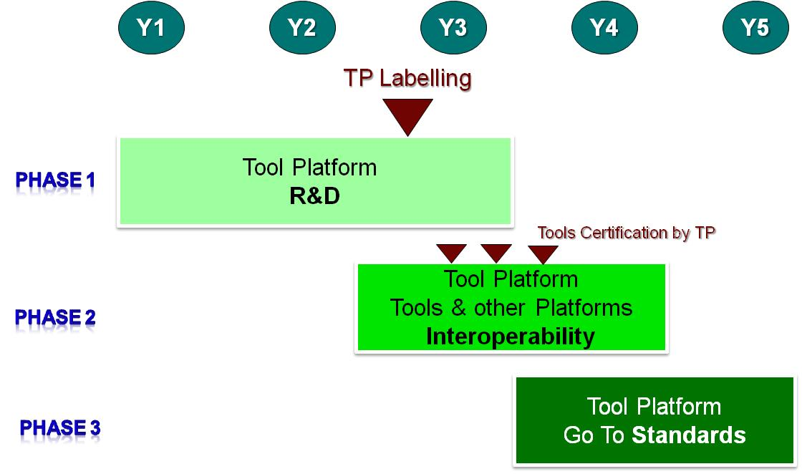

Example of a typical Tool Platform progress plan

- ARTEMIS-IA will reassess after 3 years the platform label in order to ensure that progress has been achieved along the labeling criteria, especially those on organization of the tool platform support and the TRL level.

Note on Artemis-IA role:
Artemis-IA is not a software engineering body, and has not the mission to carry-out a technical expertise of the architecture, quality, relevancy to market of the candidate Tool Platforms. Therefore Artemis-IA will check availability of documentation, clearness, completeness rather than content.
Artemis-IA mission is to create an environment, in which an eco-system of platforms will develop and evolve in a dynamic fashion. The viability and success of each platform will be decided by its market, i.e. by the projects electing to develop on this platform.
Artemis-IA mission is of course also to strongly promote a dynamics of interoperability across platforms, as described in the MASP.

Annex A.

Technology Readiness Levels

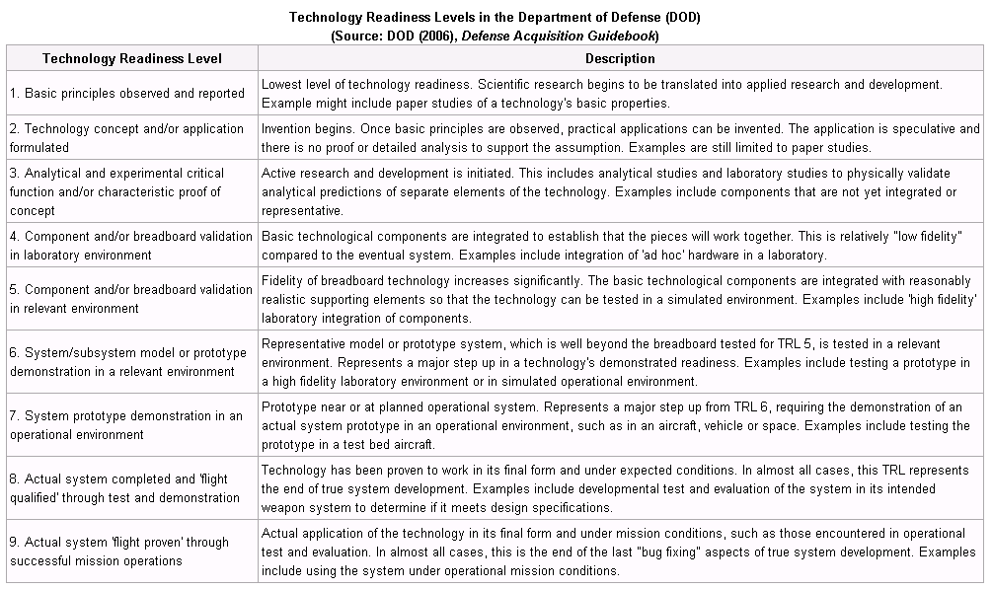

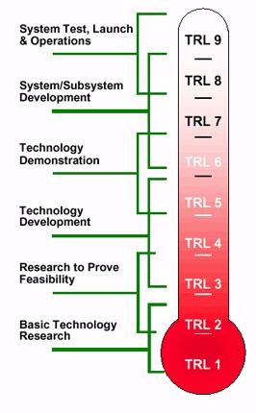

Annex B
Some Practical Guidelines for Tool Platforms Stakeholders

Steps for Tool Platforms Program Managers:

1- Declare the project as a Tool Platform candidate
At project submission time or at any time after,
- Plan funding for Tool Platform related activities i.e. ensure that funding for the Tool Platform activity has been properly secured
- Get registered with the Artemisia Tool Platforms Working Group
- Join the Artemis Tool Platform community and connect to the Artemisia Tool Platform Working Group blog
http://member-platform.artemisia-association.org/phpBB3/index.php
- Interact on the blog about your project with Artemisia partners, and the Tool Platform Working Group

2- Interact with Artemisia Tool Platform Community in order to converge
- On your Tool Platform Functional Capability and Architecture
- On your Tool Platform’s Tool Interfaces or plugins when applicable
- On XML Streams, Web Services, …
- On your Tool Platform Interoperability with other Tool Platforms when applicable, in particular for overlapping platforms
- On Interoperability Scenarios
- On Data Import / Export Definition
- On XML Import / Export Definition.
- On Mapping your XML Import/Export to other platforms XML Import / export definitions
- On Shared Web Services
- On the ownership, resources and organization that will be affected to the interoperability joint work

3- Define the Test, Validation, Certification mechanism
- Test Procedures
- Test Data
- On-line test & certification service, qualification evidences in terms of scenarios

4- Apply for the Artemisia Tool Platform Label

5- Once you are labeled, certify Tools on your platform, based on your certification procedures and tests

6- Before the end of your project, set-up the maintenance organization for your platform, , with the appropriate business model

7- Plan the move toward international standards, and apply for adequate funding

8- Report your platform activity to Artemis-IA, via the Tool Platform blog

